Supplemental Figure 1
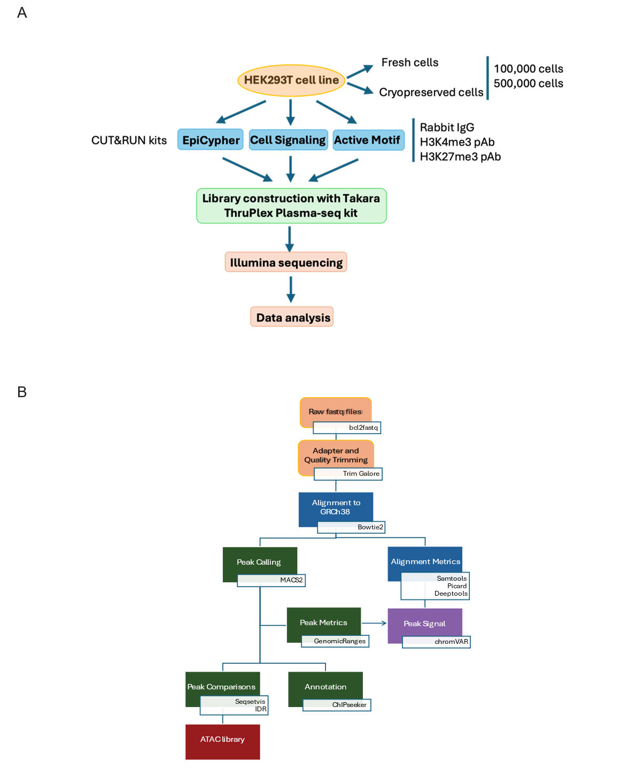
Supplemental Figure 1. Experimental Design (A) Diagram outlining the experimental strategy for DNA enrichment, library construction, and high-throughput sequencing for comparison of three commercial CUT&RUN kits (Active Motif ChIC/CUT&RUN, Cell Signaling Technology CUT&RUN, and EpiCypher CUTANA ChIC/CUT&RUN Kit). For each chemical, different cell numbers (100,000/500,000) and samples prepared fresh or cryopreserved were compared. Affinity enrichment was performed with antibodies against H3K4me3 and H3K27me3. An anti-IgG antibody was used to generate nonspecific background control libraries. The enriched DNA was processed with the Takara ThruPLEX Plasma-seq Kit before next-generation sequencing. (B) Diagram outlining the central data processing and analysis steps. Downsampled read files were processed before read quality control, alignment, and peak calling. Peaks were analyzed for signal quality and reproducibility using various bioinformatics tools and the R package. ATAC-seq data were integrated into the analysis and compared to the CUT&RUN peak distribution to measure the accuracy of each CUT&RUN dataset.

Supplemental Figure 2
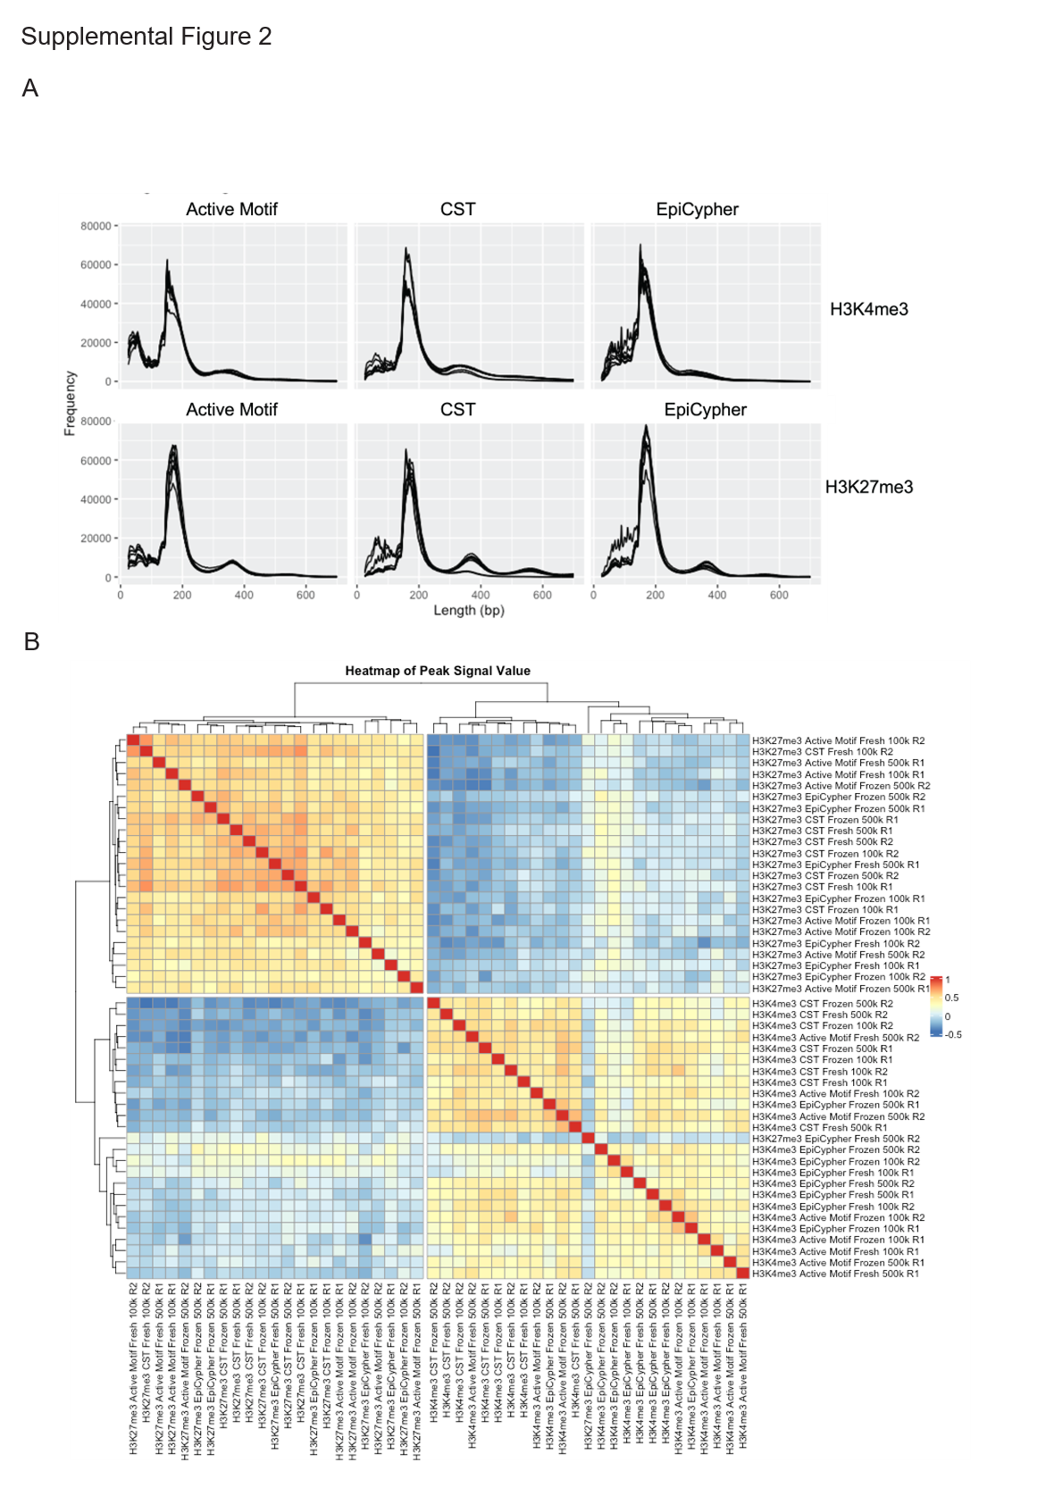
Supplemental Figure 2. (A) Fragment length distribution plot based on mapped paired-end reads showing predominantly mononucleosomal peaks of approximately 150–180 bp in length. (B) Heatmap and hierarchical clustering based on read distribution.

Supplemental Figure 3
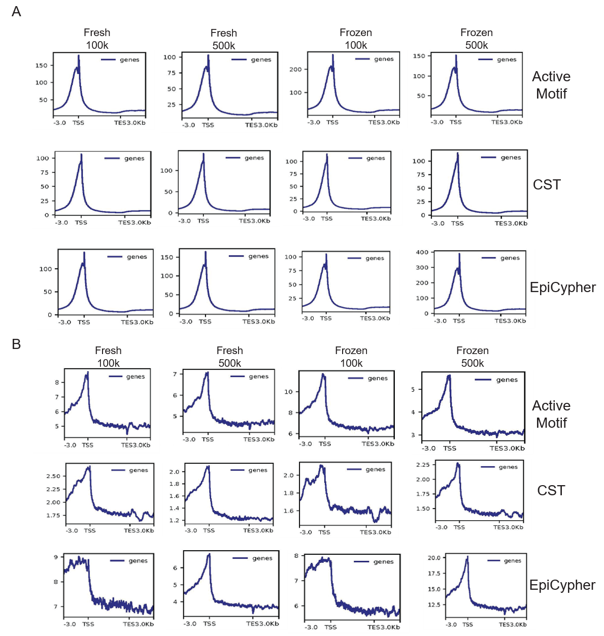
Supplemental Figure 3. (A) Profile plots displaying the average H3K4me3 signal distribution based on normalized, stacked reads. (B) Profile plots displaying the average H3K27me3 signal distribution based on normalized, stacked reads.

Supplemental Figure 4
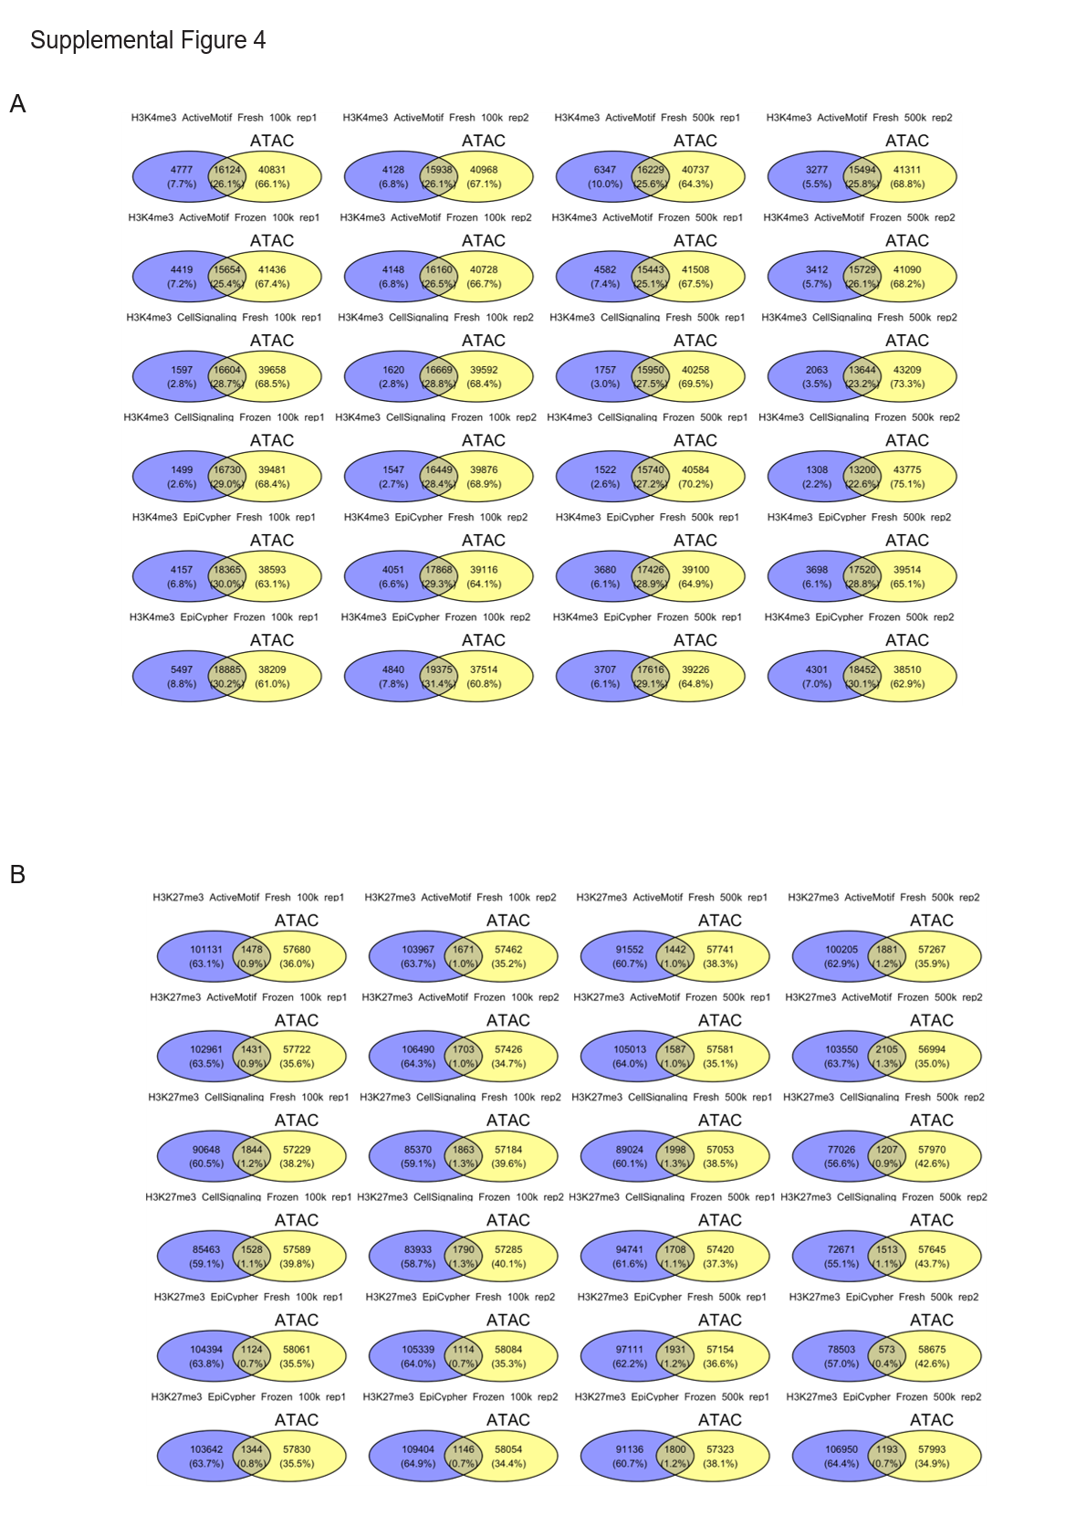
Supplemental Figure 4. (A) Venn diagrams showing overlap between H3K4me3 peaks and ATAC-seq peaks. (B) Venn diagram showing overlap between H3K27me3 peaks and ATAC-seq peaks.

Supplemental Figure 5
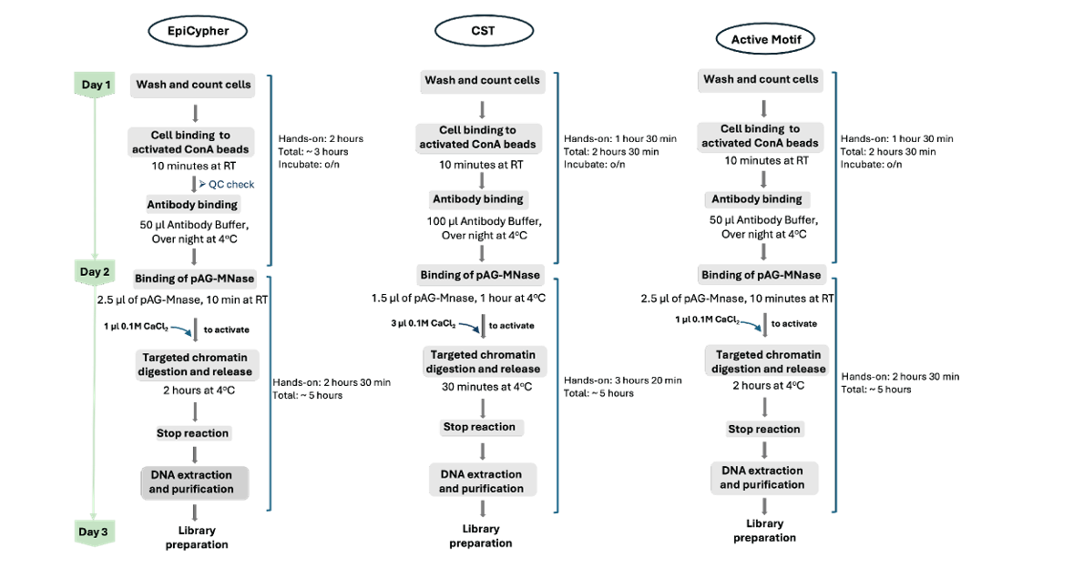
Supplemental Figure 5. Flow chart illustrating the key steps of the protocol from enrichment to library preparation. Hands-on time experiences are highlighted.

Supplemental Table 1.
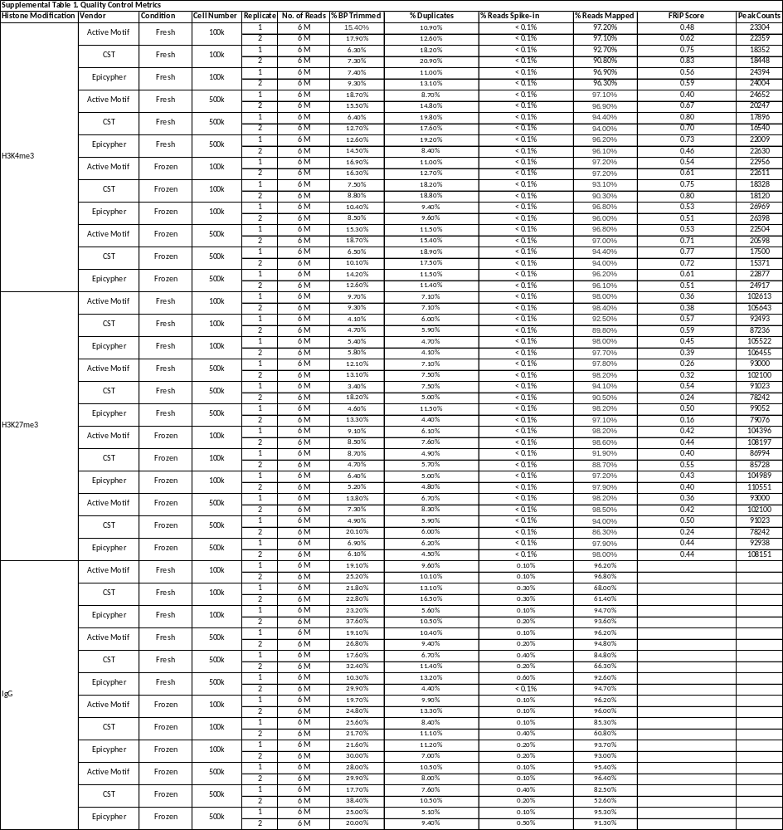

Supplemental Table 2.
